**How to calling Deepseek locally in VSCode +Continue**

The artificial intelligence revolution is booming, and Deepseek-R1 is at the forefront of this revolution. This powerful large language model LLM is comparable to top artificial intelligence models such as CHATGPT and performs well in reasoning, coding and problem solving. And it can be run on your own computer.

With Deepseek-r1, you have a fast, private, and cost-effective coding assistant ready to help you when you need it.

After some research, I found a great tool: it can be seamlessly integrated with VSCode for free. Next let me show you step by step how to configure

**1. Install Ollama**

First, you need Ollama, a lightweight platform that allows you to run large language models locally. Ollama is the basis for setting up Deepseek-r1 because it allows you to easily manage and run Deepseek on your computer.

**（1）Download and install Ollama:**

Ollama official version: **https://ollama.com/**, select the windows version to download and install Ollama

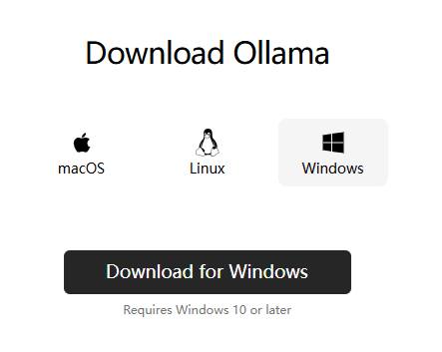

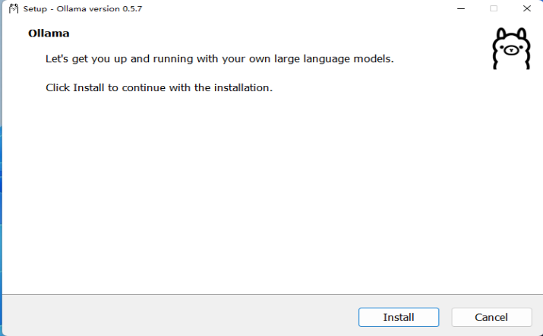

If Ollama is installed successfully, it will show as below:

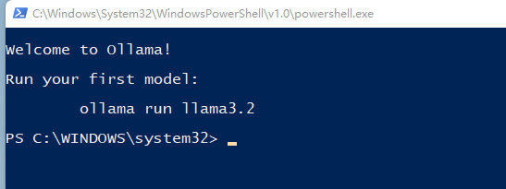

**（2）Deploy Deepseek locally (ollama run deepseek-r1:7b):**

After installing Ollama, it is time to deploy Deepseek-r1 locally. Open the terminal and run the following command

bash

ollama run deepseek-r1:7b

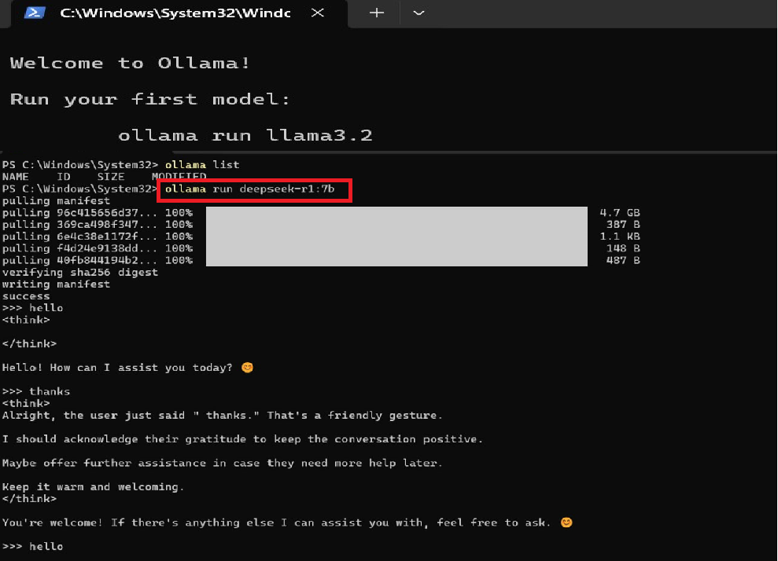**2.Install the Continue plugin in VSCode**

Now, we are bringing Deepseek-r1 into Visual Studio code. To do this, we will use the Continue plug-in, which connects VSCode with large language models like Deepseek-r1, allowing you to interact with deepseek-r1 directly in the coding environment. you can install it by following these steps:

1. Open VSCode and enter the extension store (shortcut key Ctrl+Shift+X).
2. Search for "Continue" and install the official plugin.

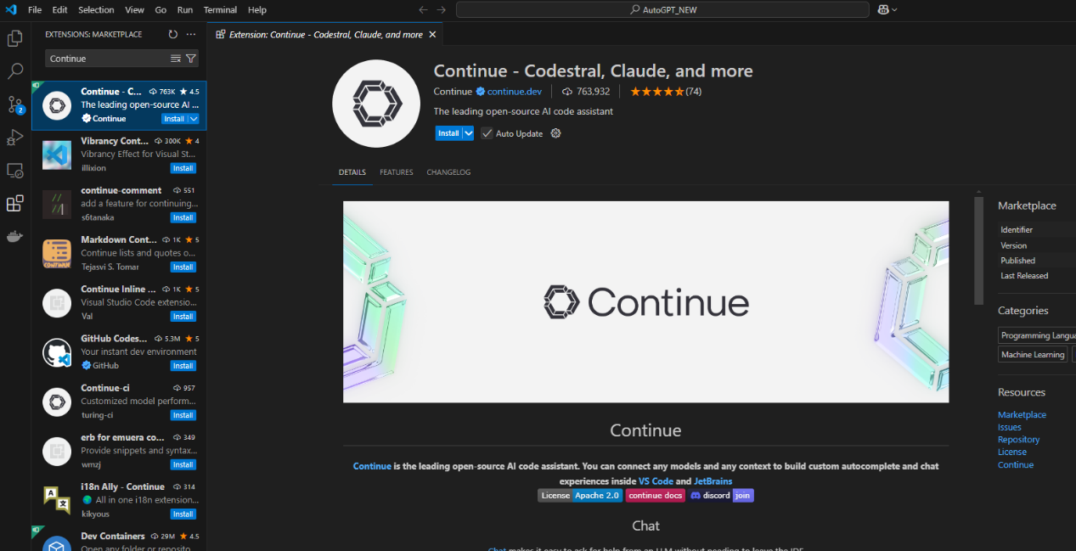

After you installed the Continue plugin, it will show on the left as below:

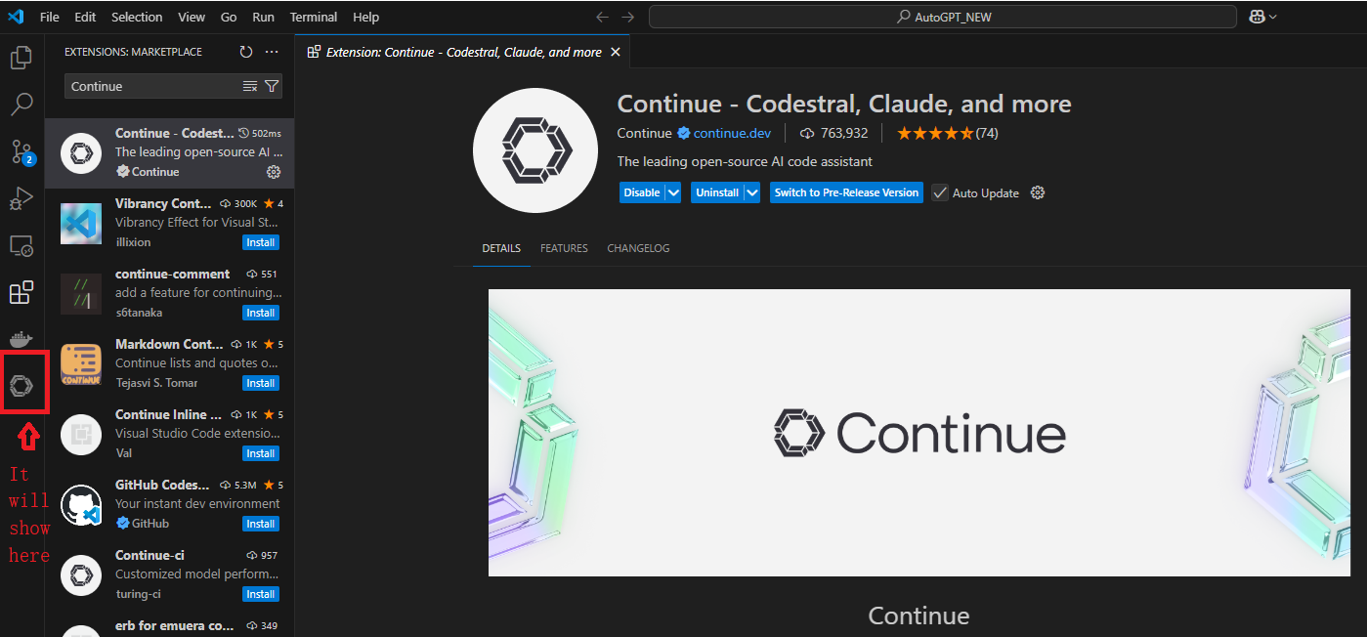

**3. Configure Deepseek-r1 in Continue**

After installing Continue, connect it with Deepseek-r1. Follow below steps to configure:

1. Click the icon in the VSCode activity bar to open the Continue interface
2. Find the model selection button in the chat window
3. Click the button, select Ollama as the platform, and select Deepseek-r1 from the list of available models

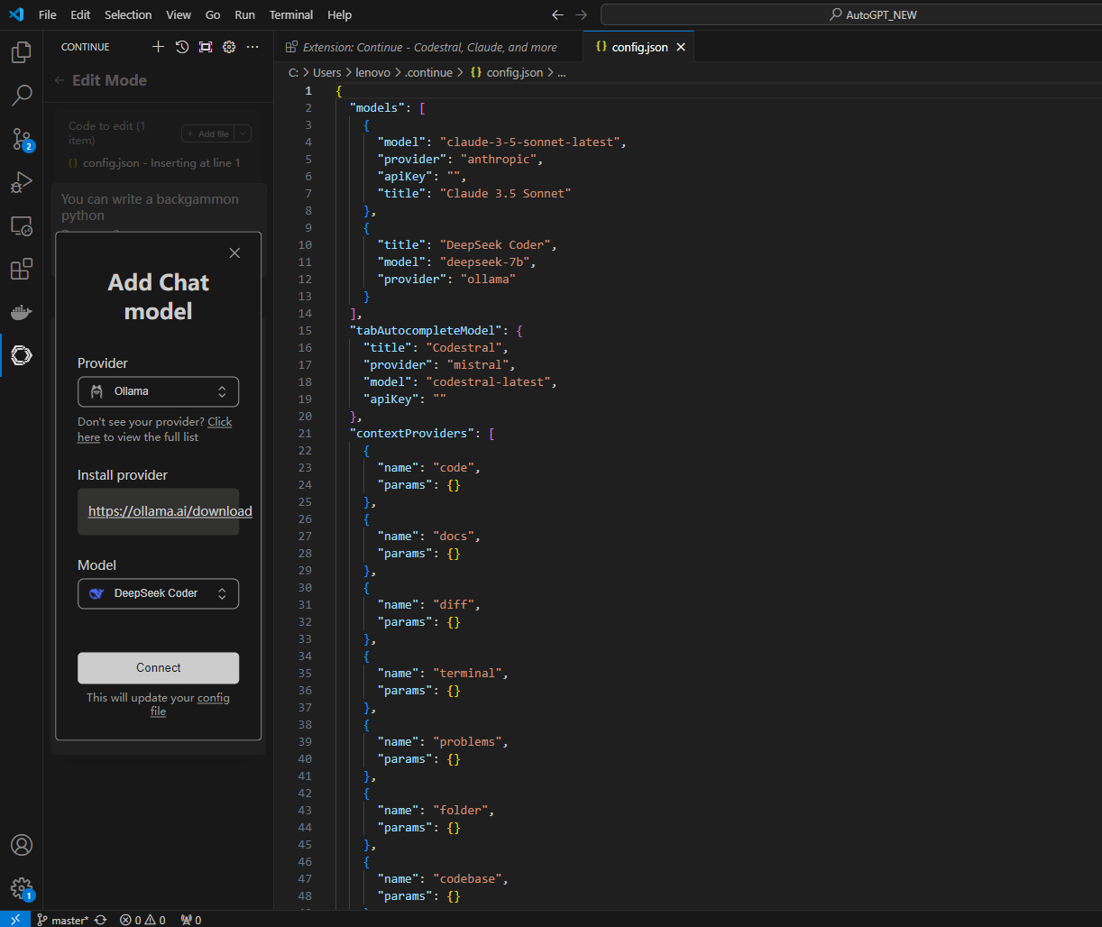

**4.Write code:**

After you configured Deepseek in the continue plugin, you can let it to write code in Continue plugin now, but the file will not be automatically generated, so you need to create a file by yourself first, then Press Ctrl+I, and enter your requirements

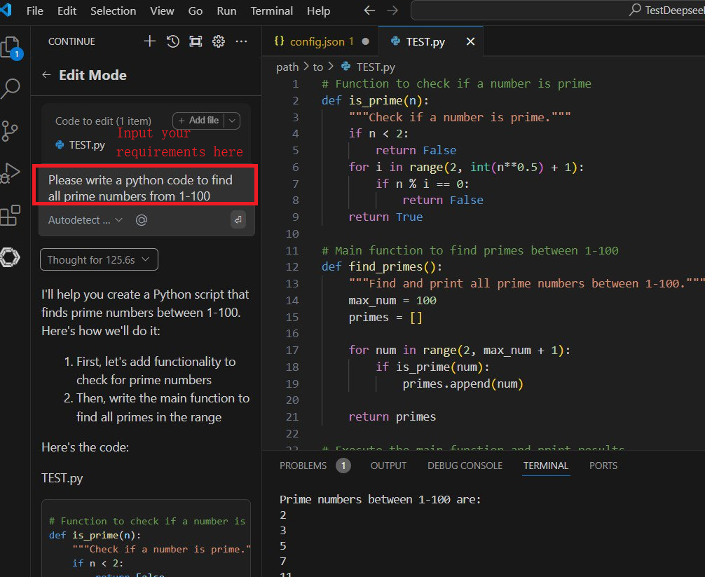

If the test result is not correct or is not your expected result, you can tell it the error message or your expected result, and it will modify the code.

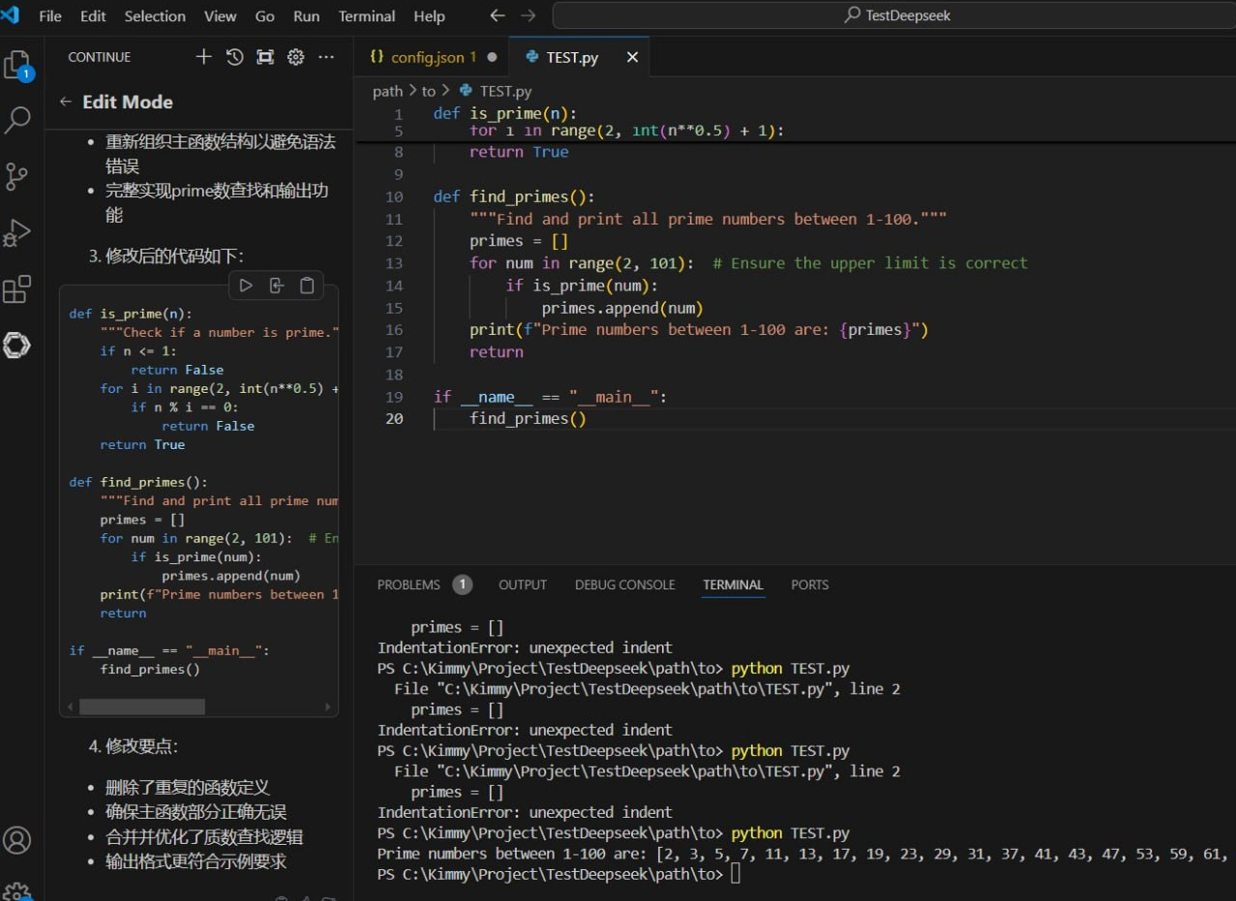

**What are the main benefits of using locally deployed deepseek+VSCode+Continue?**

1. Completely free

Run locally without paying, no OpenAI API or DeepSeek API subscription required, avoid high API fees.

Unlimited calls, unlike cloud APIs that have request limits, can generate code anytime and anywhere.

2. Privacy & Security

Code is not uploaded to the cloud and all requests are handled locally, protecting the confidentiality of corporate code or personal projects.

Suitable for internal projects, such as finance, medical, military, scientific research institutions and other high-security industries.

3. Low latency, fast response

Run locally to avoid API network delays and greatly speed up AI code completion.

It is not affected by API current limiting, unlike the OpenAI/DeepSeek API which may slow down the response due to traffic peaks.

It is suitable for low network speed or no network environment, and offline development can also be completed with AI code.

4. Compatible with VSCode ecosystem, automatic completion

Continue + local DeepSeek implements code completion. Enter the function name to intelligently complete the code.

Supports VSCode terminal/command line interaction and calls the local AI code generator directly in the terminal.

Integrate VSCode's existing functions (such as Debug, Git, unit testing) for intelligent optimization.

**In conclusion**

If you have a PC or server with good performance, using locally deployed DeepSeek + VSCode+ Continue is definitely the most economical, efficient and safe AI programming method 🎯.

✅ Free, no API fees

✅ Privacy and security, the code will not be leaked

✅ Low latency, faster completion

✅ Customizable to improve code quality

✅Supports VSCode smart completion

✅ Suitable for Python, C++, Java and other languages

In this way, you can use DeepSeek-R1 locally as an AI coding assistant to write and optimize code efficiently 🚀!